SafetyNews
Hanson Masonry & Concrete, LLC

This week’s highlight: Struck-by Hazards

"Struck-by" hazards include any falling or flying objects and vehicle-related accidents, including being crushed by overturned vehicles or being struck by a vehicle. Workers are at risk: beneath cranes or scaffolding, near power tools, and when performing activities involving pushing, pulling, or prying so as to cause an object to become airborne. Constructing masonry walls, for instance, is a dangerous project because of the tremendous loads supported and the instability of the structure during the building process.

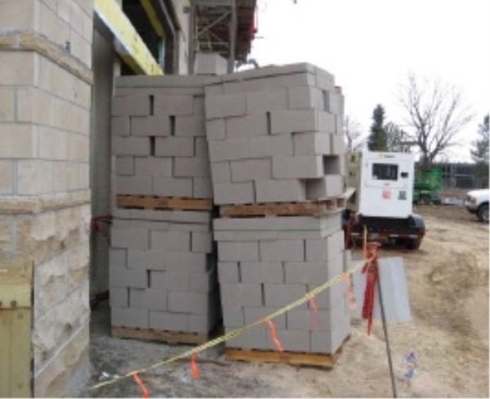
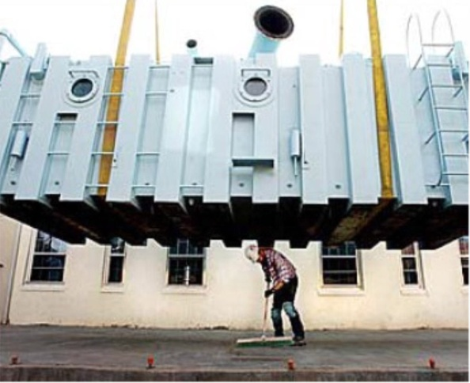
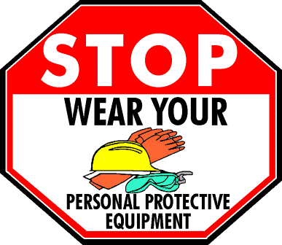
These masonry blocks should have been stacked on a level surface!
Never work under a suspended load.

- Falling Objects
  - Rigging Failure
  - Loose or Shifting Materials
  - Equipment Tip-over or Malfunction
  - Lack of Overhead Protection
- Vehicle and Equipment Strikes
  - Backing Incidents
  - Workers on Foot
- Flying Objects
  - Unguarded equipment/parts
- Hang slings and other lifting devices in a dry place when storing
- All loads must be properly rigged by a qualified person
- Job materials should be stacked on a level surface
- Hardhats and safety glasses must be worn at all times
- Never work under a suspended load
- Wear high visibility clothing
- A “Limited Access Zone” must be established on the unscaffolded side of a masonry wall
- Never disable any guard or protective device on your equipment
- Only trained and certified employees are allowed to operate forklifts
The following personal protective equipment (PPE) is provided to all employees:

Hardhats
Safety Glasses
High Visibility T-shirts and Vests
Gloves
Particulate respirators
Ear plugs

If you need any PPE, let your supervisor know, or contact the safety coordinator: (715) 229-4021.

