SafetyNews
Hanson Masonry & Concrete, LLC

This week’s highlight: Caught-in Injuries

If you have ever slammed your finger in a door, you can appreciate the pain associated with this common type of caught-in injury. Take the time to learn about the caught-in hazards in your workplace so you don’t learn about the consequences first hand.
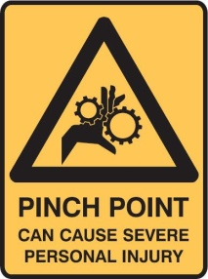

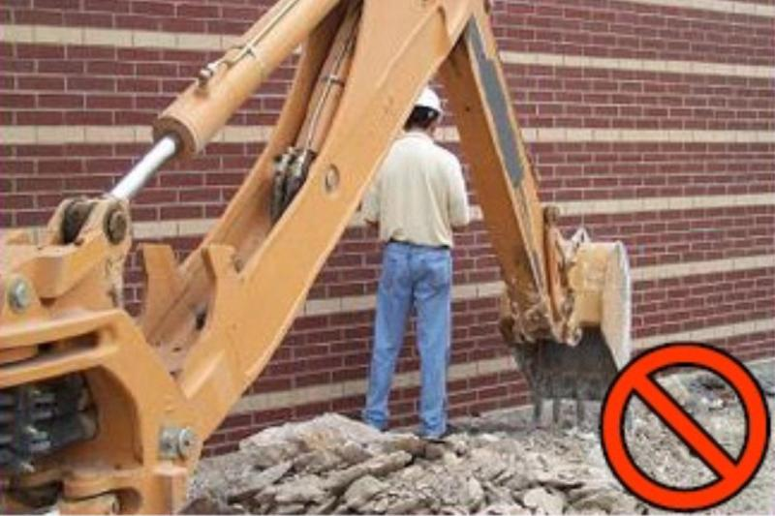
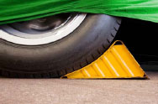
Caught-in injuries occur when a part of the body is squeezed, pinched, or crushed in machinery or other objects.
- Working on moving equipment
- Using unsafe equipment
- Lack of training
- Inadequate guarding on machines
- Incorrect hitching practices
- Distraction
- Loose clothing and jewelry
- Safe-guard against contact with moving parts
- Shut off power, perform lock-out/tag-out, and release any remaining energy before unjamming, servicing, lubricating, or adjusting machinery
- Replace guards after servicing and before resuming use of equipment
- Avoid wearing jewelry and tattered or loose clothing around machinery, and wear hair short or tucked inside clothing
- Avoid stepping or reaching across running equipment or machinery
- Chock vehicles during loading and unloading

After you have read this SafetyNews and signed below, there are five ways to earn your 50 Safety Points:
HMC
HANSON
MASONRY AND CONCRETE, LLC
SRP
afety
ecognition
rogram

- Give it to your Supervisor or Safety Coordinator
- Fax it to me: (715) 229-9111, ATTN: Kristie
- Send me an email confirming that you have read it: kkohn@hansonmc.com
- Call me and tell me you read it: (715) 229-4021
- Mail it to me: Hanson Masonry & Concrete, LLC
ATTN: Kristie Kohn
P.O. Box 272
Owen, WI 54460

I, ______________________________________________, have read this edition of Safety News.
(Your printed name here)

Signed,

(Your signature here)

**Would you rather have your safety news sent by Email? Let me know: kkohn@hansonmc.com**
You can read SafetyNews online at: www.hansonmc.com

Loading heavy equipment on and off flatbed trucks and trailers is so common that it’s easy not to give it a second’s thought. But a recent report on the number of fatalities suffered in performing these tasks should alert workers to give the job at the very least a second thought.

Between 1992 and 2003, nine construction workers on average were killed each year while loading and unloading mobile equipment from flatbed trucks and trailers. Loading appears to be more dangerous than unloading, as 70 percent of the deaths occurred while loading mobile equipment.

Take precautionary safety measures:
1. Have the flatbed truck or trailer parked on level, stable ground.
2. Make sure the trailer and ramp is wide enough for the mobile equipment being loaded.
3. Make sure the trailer ramp is long enough to avoid steep angles when loading or unloading the equipment.
4. The equipment operator should be qualified and trained in operating the equipment being loaded or unloaded.
5. Workers on foot should be alert to the movement of the equipment being loaded or unloaded.
6. Have a spotter to provide directions to the operator in positioning the equipment while loading/unloading.
7. The flatbed truck should have brakes set and motor turned off.

Cause of death | % of Deaths
Overturns while loading/unloading  Struck by mobile equipment/trailer  Caught in/between | 