

Toolbox Talk

Discussion:
Caught-in hazards are one of the four biggest hazards found on construction sites. Caught-in hazards occur when a worker could be caught inside of or in between different objects.

Caught-in Hazards:

- Cranes and Heavy Equipment

Caught in hazards are often created when working around heavy equipment. Never place yourself between a piece of heavy equipment and an immovable object, and never work in the swing radius of rotating equipment. Always work at a safe distance away from equipment.

- Tools and Equipment

Caught-in hazards exist when workers remove or disable guards on tools or equipment. Never use equipment that is missing guards or other protective devices. Never place your hands or body near moving parts. Gloves, long sleeve shirts, jewelry, or loose fitting clothing can be hazardous if caught in moving parts.

- Materials Handling

Use caution when handling materials, especially when stacking or storing them. Do not place yourself between materials and an immovable structure.

- Trenches and Excavations

Workers inside of an excavation must be protected from a cave-in. Workers are exposed to a cave-in when there are unprotected sides. Workers can be caught in between the sides of the excavation and pipes or other objects inside the excavation. Never work inside an excavation where water is accumulating.
Hanson Masonry &

Concrete, LLC
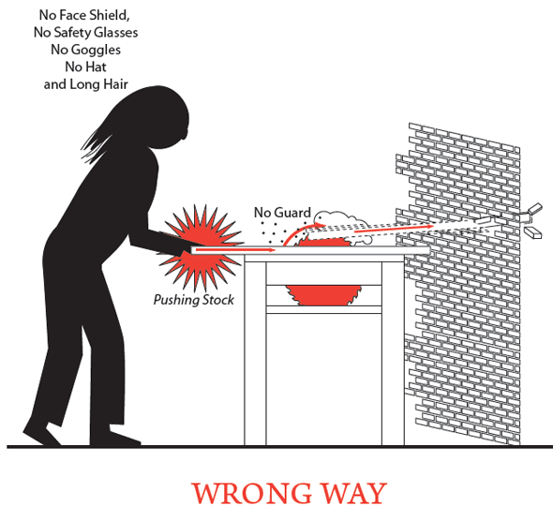

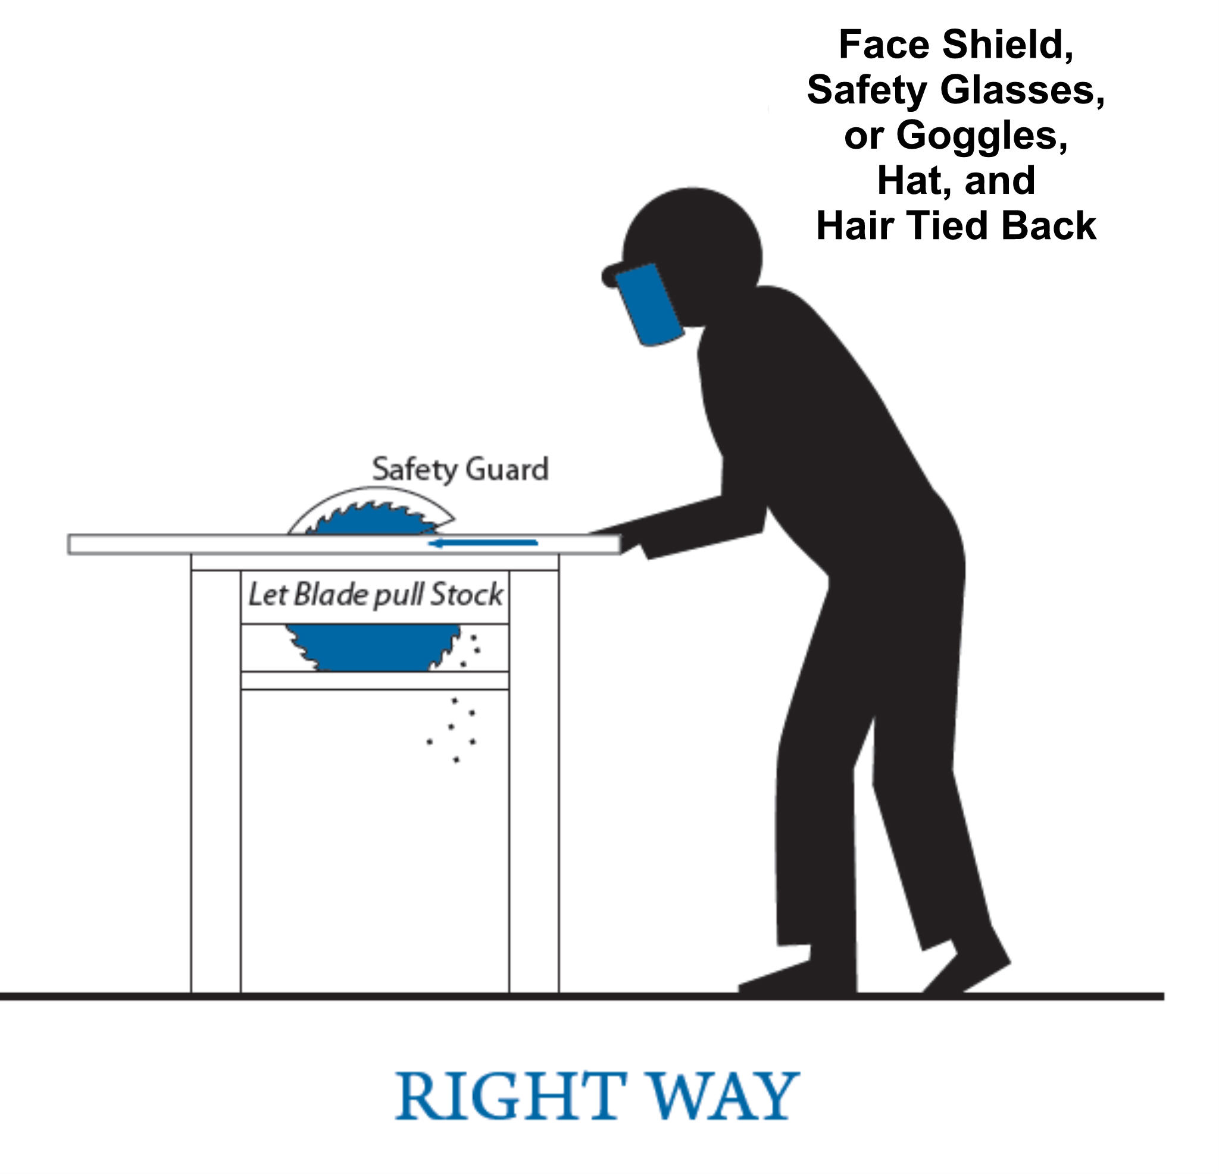
Toolbox Talk Attendance

Hanson Masonry & Concrete, LLC

Name (Please print clearly) Name (Signature)

