

Toolbox Talk

Discussion:
Today’s toolbox talk focuses on working safely around overhead and underground electric power lines and near natural gas pipelines. By following the procedures we’ll cover here today, you can keep yourself and your co-workers safe and on the job. On the other hand, if you cut corners where utility lines are concerned, you put yourself and your co-workers at risk of serious injury and even death.

Respect the Power of Electricity
- When you arrive at a jobsite, always identify power lines and high-voltage equipment, and point them out to your co-workers.
- Assume all overhead power lines are energized, including service drops running between poles and buildings.
- Check the site daily, because conditions might change.

Always Observe the Ten Foot Rule
- OSHA requires that you keep yourself and your equipment at least ten feet away from overhead power lines.
- Higher voltage lines require greater clearances. Contact Xcel Energies Builder Call Line for clearance information: 1-800-628-2121.

If Heavy Equipment Contacts a Power Line
- Both the equipment and the line should be considered energized.
- If you can do so safely, move the equipment away from the line.
- Stay on the equipment and warn others to stay away.
- Call 911 and Xcel Energy’s Electric Emergency Line: 1-800-895-1999.
- If fire or other danger forces you off, jump clear, keeping both feet together and without touching the equipment and ground at the same time.
Hanson Masonry &

Concrete, LLC
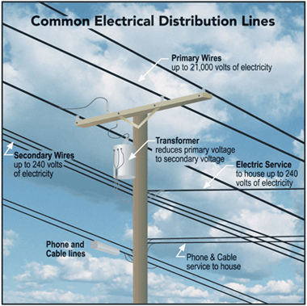

If equipment contacts an overhead power line, the ground around the equipment will be energized. If you must leave the equipment, jump clear and land with your feet close together while maintaining balance. Shuffle away using very short steps (a). Using too large a step could put each foot in a different voltage zone and electrocute you (b).

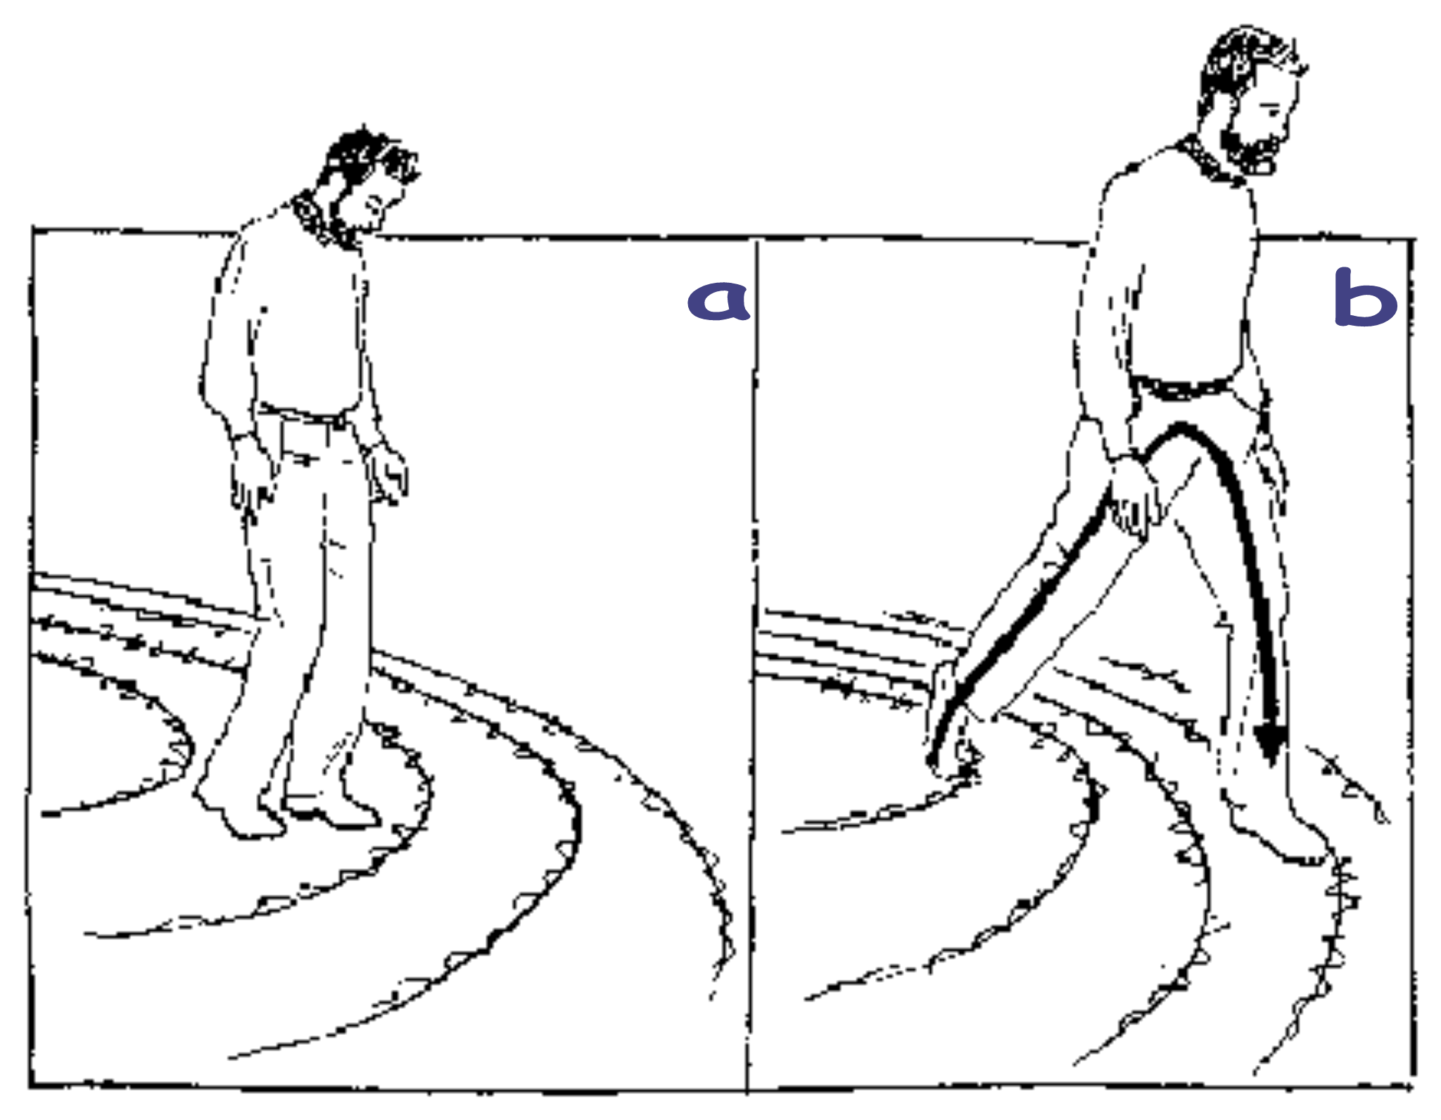

Toolbox Talk Attendance

Hanson Masonry & Concrete, LLC

Name (Please print clearly) Name (Signature)

